Assignment 4

1. Java program for swapping of 2 numbers

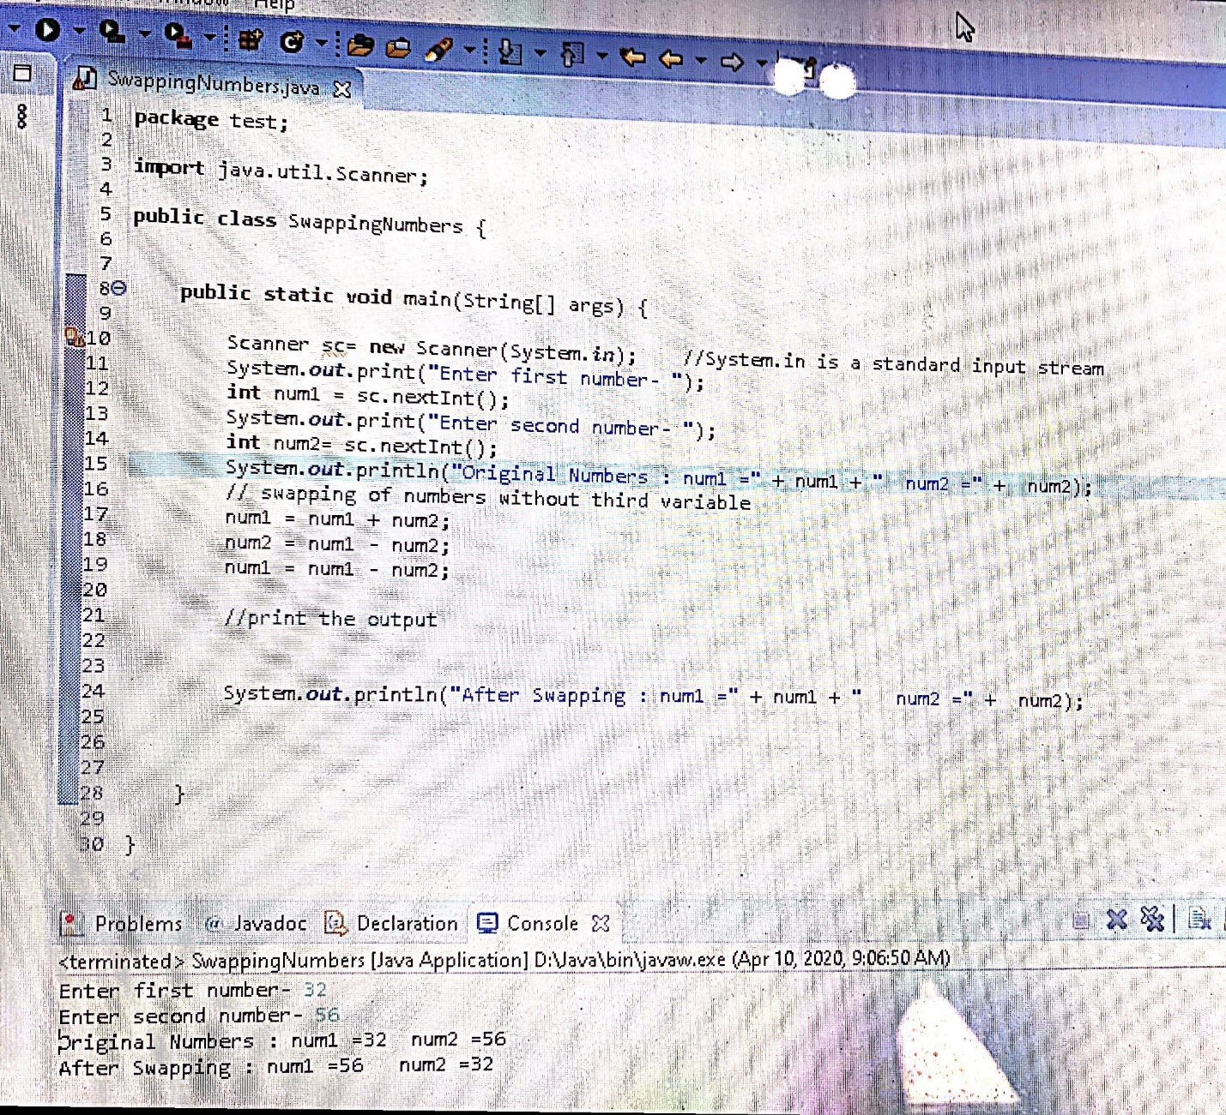

1. Adding digits of a number



1. What is Obfuscation?

Java source code is compiled to a class file that contains byte code. The Java Virtual Machine needs only the class file for execution. The problem is that the class file can easily be decompiled into the original source code using Java decompiler tools. The best solution to prevent reverse-engineering is to obfuscate the class file so that is will be very hard to reverse-engineer. According to the dictionary Obfuscate means **“to make obscure or unclear”.**

1. How many keywords are in Java? List any 10

In the **Java** programming language, a **Keyword** is any one of 51 reserved words that have a predefined meaning in the language; because of this, programmers cannot use **keywords** as names for variables, methods, classes, or as any other identifier.

class, if, else, while, do, int, byte, void, boolean, public, static, for, private, protected.

1. Is Floating datatype follow cyclic nature or not? NO
2. Write the difference between logical and bitwise operator

* The logical and operator ‘&&’ expects its operands to be boolean expressions (either 1 or 0) and returns a boolean value.  
  The bitwise and operator ‘&’ works on Integral (short, int, unsigned, char, bool, unsigned char, long) values and return Integral value.

1. **Pre**-**increment** is **faster** than **post**-**increment** because **post increment** keeps a copy of previous (existing) value and adds 1 in the existing value while **pre**-**increment** is simply adding 1 without keeping the existing value.

**For Loop**

1. for (initialization; condition; increment) {
2. //do something
3. }

Use this when you are sure about the number of iterations you need to run something.

**While Loop**

1. while(condition) {
2. //do something
3. }

Use this when you are not sure about the number of iterations and the condition changes depending on what you do inside the loop.

**Do-While Loop**

1. do
2. {
3. //do something
4. } while(condition);

Use this when you want to run something at-least once and based on the conditions run it further till the condition fails.